**Course name**

**HOP00 - Getting started with Jira, Confluence & Agile development**

05/02/2021 Developed by Kim Nguyen

Center for Information Assurance (CIAE) @City University of Seattle (CityU)

 

**Before You Start**

* The directory path shown in screenshots may be different from yours.
* Some steps are not explained in the tutorial**.** If you are not sure what to do:
  1. Consult the resources listed below.
  2. If you cannot solve the problem after a few tries, ask a TA for help.

**Learning Outcomes**

From this HOP, students will be able to:

* Create an account in Jira.
* Create an account in Confluence.
* Understand SCRUM development and Atlassian software.

**Resources**

* <https://www.atlassian.com/agile/tutorials/how-to-do-scrum-with-jira-software>
* <https://scrumguides.org/scrum-guide>

**Preparation**

**SCRUM development**

What is it and why?

SCRUM is an agile development methodology designed for developing, delivering, and sustaining software. SCRUM is used not only in Software Development, but also used in other fields including research, sales, marketing and advanced technologies. The values of SCRUM are Commitment, Focus, Openness, Respect, and Courage.

Below are other components of SCRUM framework. Watch [THIS VIDEO](https://youtu.be/9TycLR0TqFA) to learn about SCRUM.

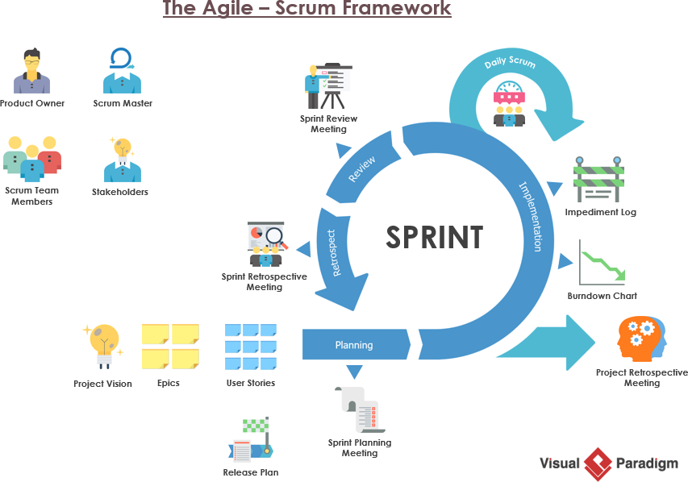

Learning and practicing SCRUM is important as it is a part of effective Software Development, and this methodology is widely applied in companies in the industry. If you would like to know more about SCRUM, visit <https://scrumguides.org/scrum-guide>

**Create a Jira account**

Jira is one of popular software used in SCRUM development, which is designed for bug tracking and agile project management. During this course, you will be using Jira to manage your Team Project.

1. Visit <https://id.atlassian.com/signup> and fill out the required information to finish the sign-up process:

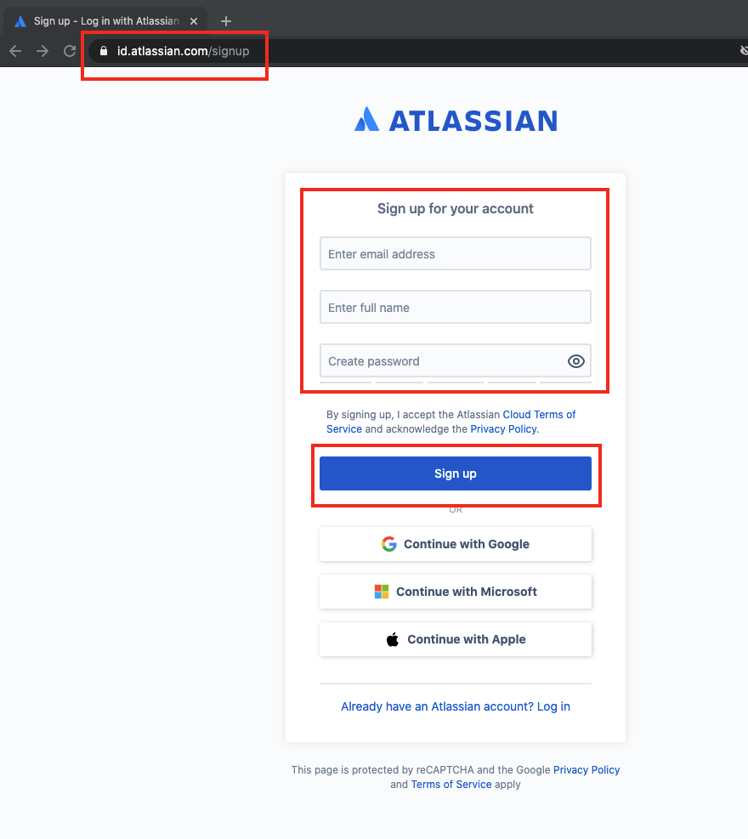

**Create a Confluence account**

**With your real name**

**2. Log in your account and Click account settings**

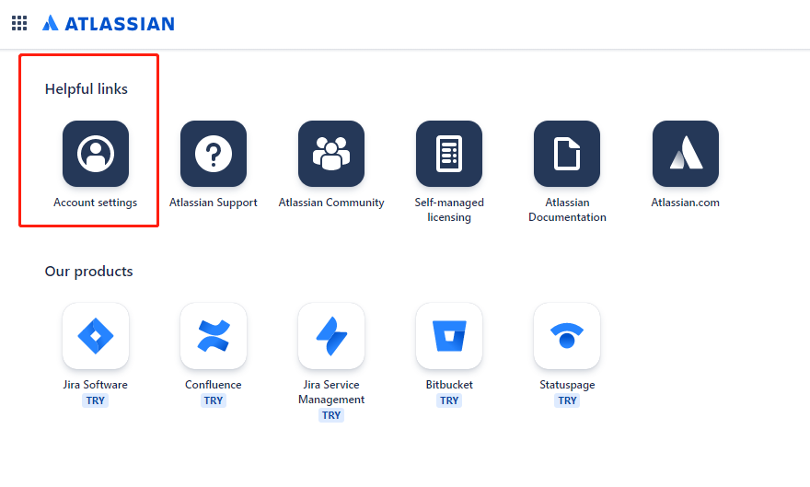

**3. Make a screenshot and save the information**

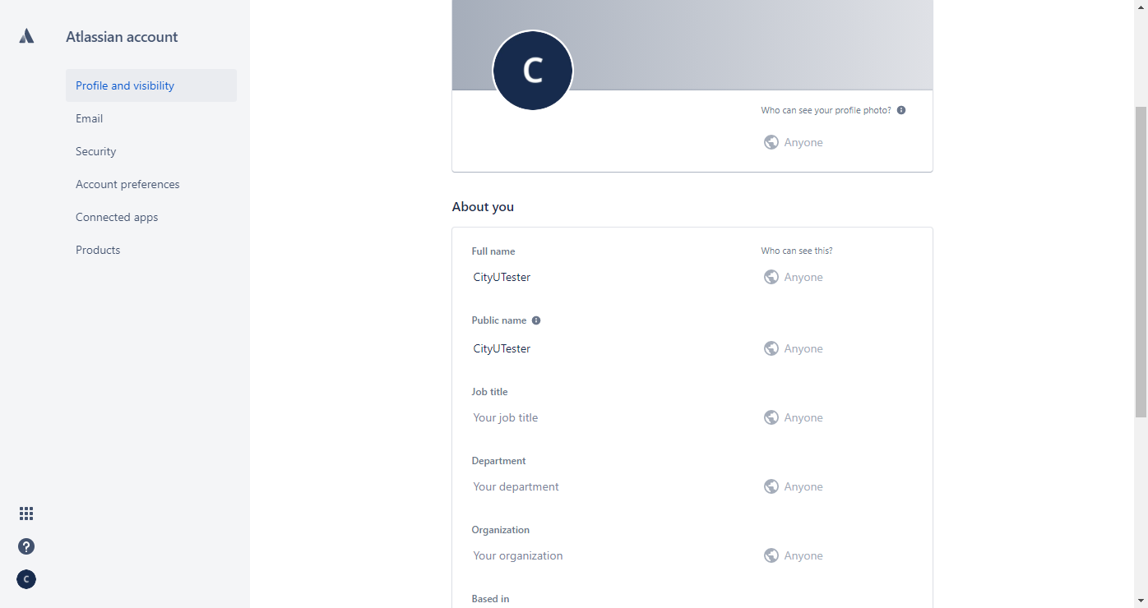

**Add your own screenshot here:**

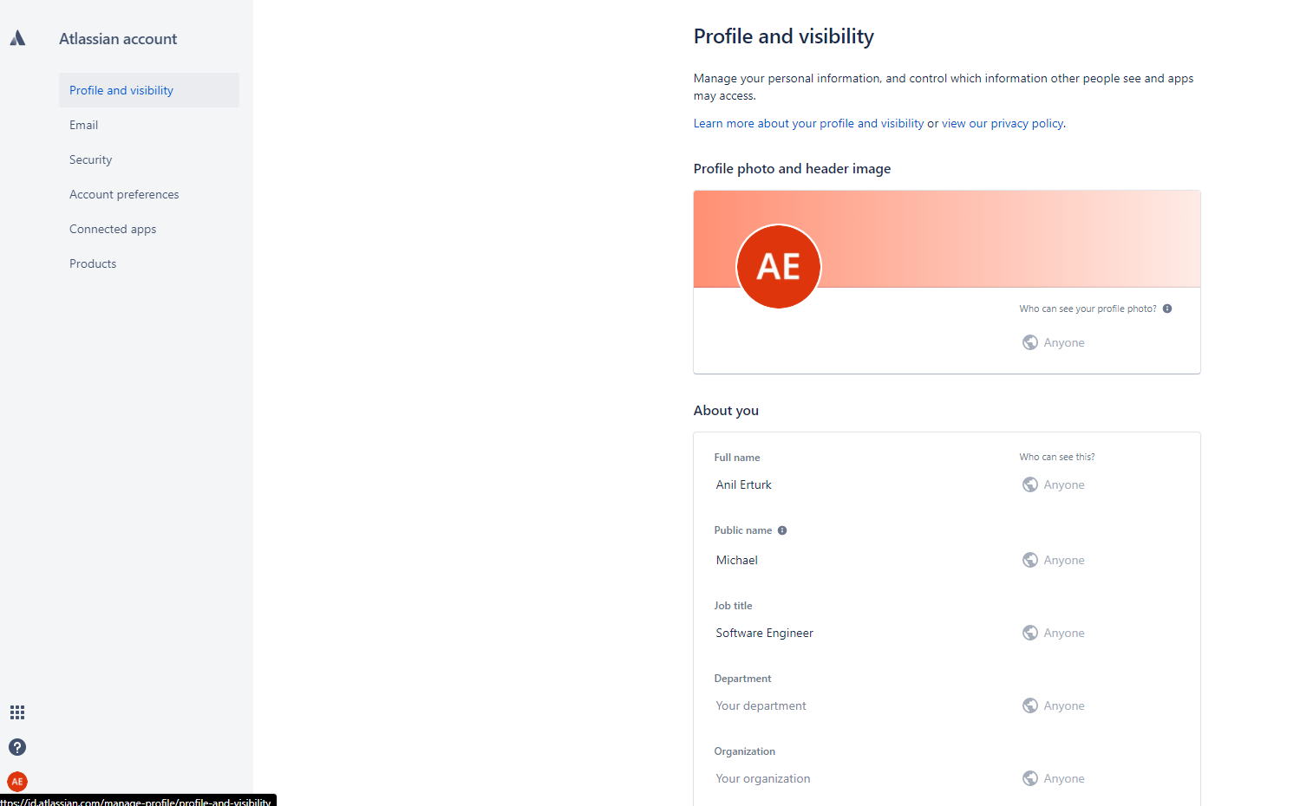

**Push your work to GitHub**

Open the terminal from the VSCode by hitting the “control” + “~” key and type the following command:

>>> git add .

>>> git commit -m “Submission for Module 2 – Your GitHub Username”

>>> git push origin master